**Forum**

**Introduction**

The forum feature in the website focuses on solving the problem of communication between members. This feature was implemented due to the live chat implementation running into problems. This feature was a backup for the live chat, and it holds the same purpose which is to enable the communication between members within the same trading platform.

This way members would be able express their views to others or have discussions about the topics they are not sure of. Providing a live chat within the same trading platform is quick and easy for members rather them going to Facebook or Twitter to speak about trading. Furthermore, members using other communications applications/websites could cause misunderstanding if they have any questions about the Vortex.

* Post questions
* View replies
* Post replies

Scenario: Members should be able to communicate with other users within the platform

User Story 1:

**Story:** As a member, I want to be able to view questions posted in the forum so that I am able to get an overview of the discussions going on and try find answers to my uncertainties.

**Detail:** All members will have access to the forum page, they will be able to navigate to the forum page which will display an input box to type questions and a button to post them. There will also be a table showing the questions posted which the members can view.

**Test:** When in the forum page, check if there is a table showing all questions posted.

UML Use Case Scenario:

|  |  |
| --- | --- |
| Use case name | View Questions |
| Participating actors | Member |
| Flow of events:  Normal flow | 1. Member is directed to main page after login 2. Member navigates to forum page 3. Member can view questions in forum |
| Flow of events:  Alternative flow | No questions:   1. Member is directed to main page after login 2. Member navigates to forum page 3. Member cannot view any questions because there are no questions in the forum |
| Pre-condition | Member can view questions |
| Post-condition | Member can view questions  Member cannot view questions |

UML Use Case Diagram:

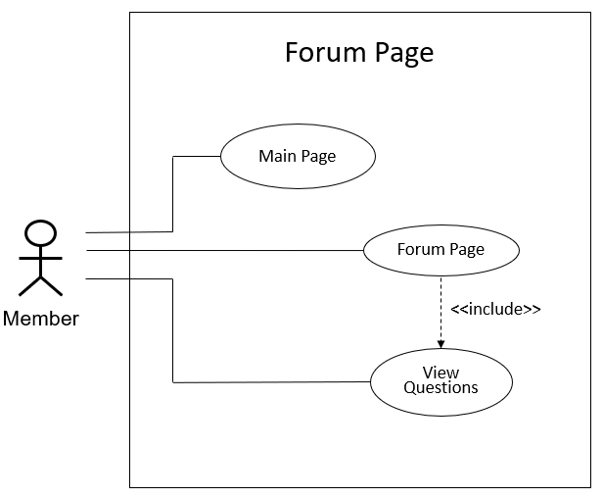

UML Sequence Diagram:

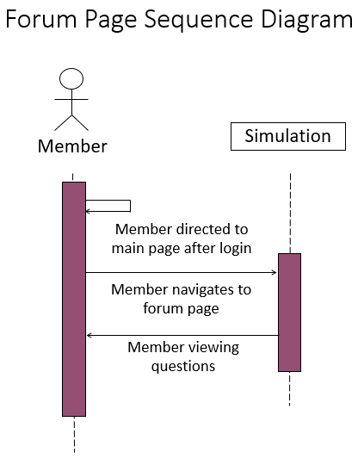

User Story 2:

**Story:** As a member, I want to be able to post questions in the forum so that I am able to discuss my views and have conversations about any uncertainties.

**Detail:** All members will have access to the forum page, they will be able to navigate to the forum page which will display an input box to type questions and a button to post them. There will also be a table showing the questions posted. Members can also use the input box to post any questions they have.

**Test:** When in the forum page, check if there is a table showing all questions posted. Check if question is posted after post button is clicked.

UML Use Case Scenario:

|  |  |
| --- | --- |
| Use case name | Post Question |
| Participating actors | API |
| Flow of events:  Normal flow | 1. Member is directed to main page after login 2. Member navigates to forum page 3. Member enters a question and then posts it |
| Flow of events:  Alternative flow | Empty string:   1. Member is directed to main page after login 2. Member navigates to forum page 3. Member leaves input box empty and then posts it 4. Question does not post due to the input box being empty |
| Pre-condition | Member hasn’t posted a question |
| Post-condition | Member posted a question  Member hasn’t posted a question |

UML Use Case Diagram:

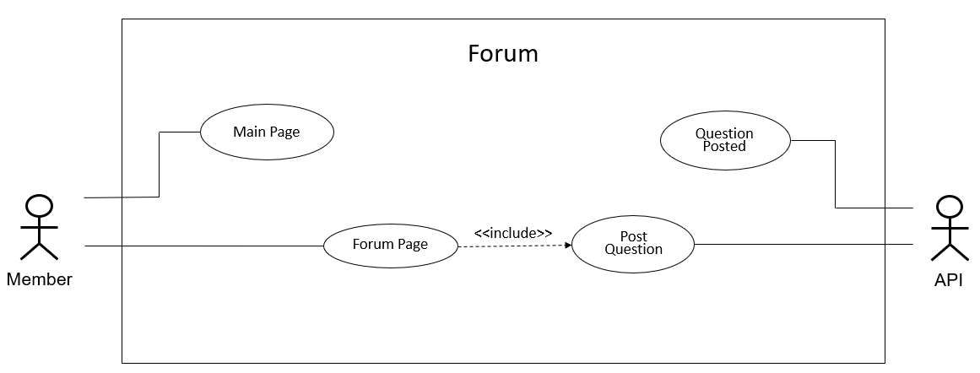

UML Sequence Diagram:

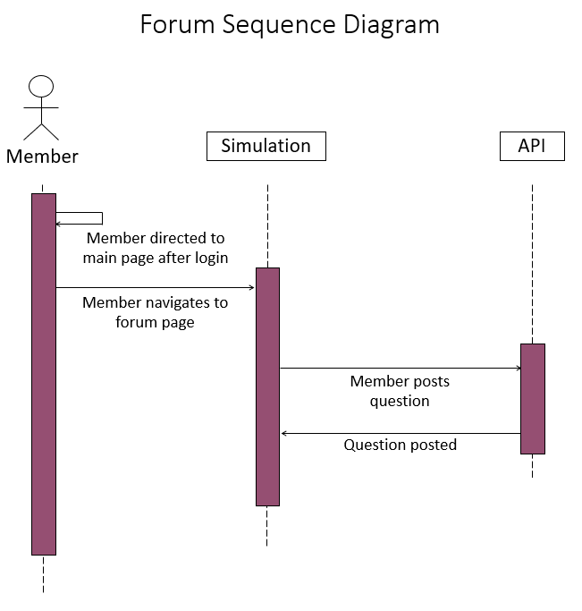

User Story 3:

**Story:** As a member, I want to be able to view replies posted in the forum so that I am able to get an overview of the discussions going on and try find answers to my uncertainties.

**Detail:** All members will have access to the forum page, they will be able to navigate to the forum page which will display an input box to type questions and a button to post them. There will also be a table showing the questions posted which the members can view. If the member selects a question, a new table will appear showing the replies for that selected question which the member can view.

**Test:** When in the forum page, check if there is a table showing all questions posted. Check if selected question shows replies.

Use Case Scenario:

|  |  |
| --- | --- |
| Use case name | View Replies |
| Participating actors | Member |
| Flow of events:  Normal flow | 1. Member is directed to main page after login 2. Member navigates to forum page 3. Member selects a question 4. Member can view replies in forum |
| Flow of events:  Alternative flow | No Replies:   1. Member is directed to main page after login 2. Member navigates to forum page 3. Member selects a question 4. Member cannot view any replies because there are no replies in the forum |
| Pre-condition | Member can view replies |
| Post-condition | Member can view replies  Member cannot view replies |

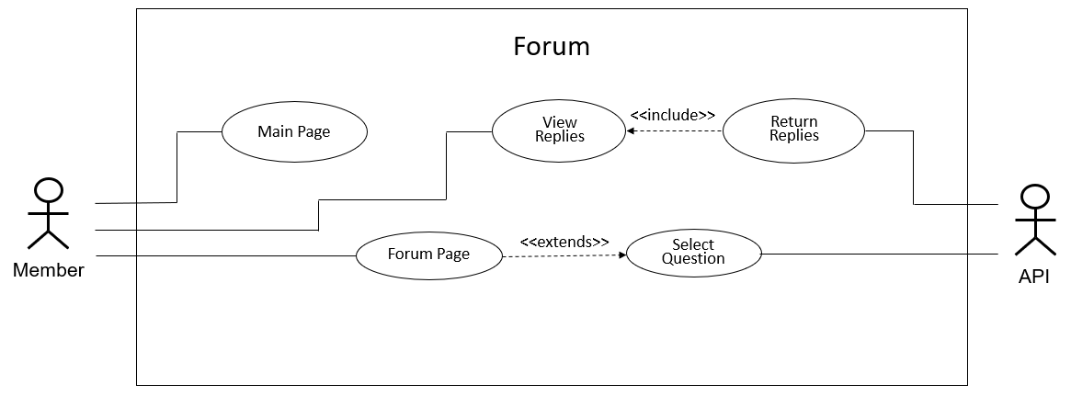UML Use Case Diagram:

UML Sequence Diagram:

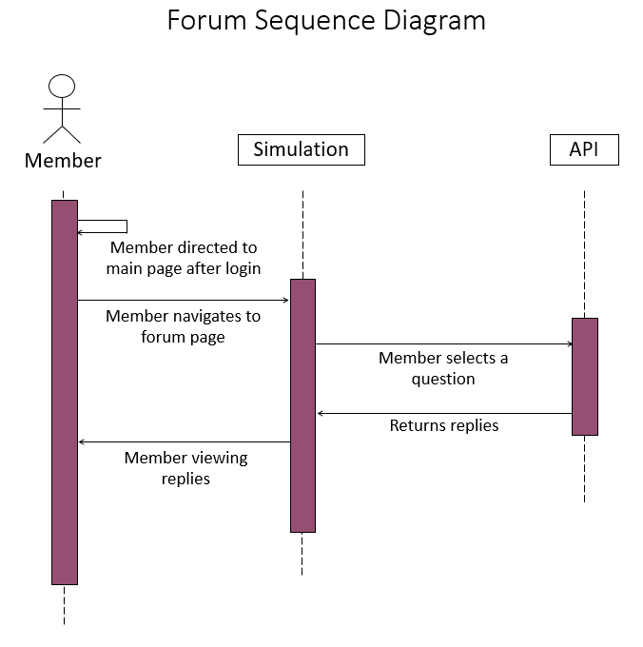

User Story 4:

**Story:** As a member, I want to be able to post replies in the forum so that I am able to discuss my views and have conversations about any uncertainties.

**Detail:** All members will have access to the forum page, they will be able to navigate to the forum page which will display an input box to type questions and a button to post them. There will also be a table showing the questions posted. Members can select a question and view the replies for that specific question. Members can also post replies for that specific question.

**Test:** When in the forum page, check if there is a table showing all questions posted. Check when a question is selected, replies are returned for that question. Also check if posting a reply inserts the reply in the replies table.

UML Use Case Scenario:

|  |  |
| --- | --- |
| Use case name | Post Replies |
| Participating actors | API |
| Flow of events:  Normal flow | 1. Member is directed to main page after login 2. Member navigates to forum page 3. Member selects a question 4. Member enters a reply and then posts it |
| Flow of events:  Alternative flow | Empty string:   1. Member is directed to main page after login 2. Member navigates to forum page 3. Member selects a question 4. Member leaves input box empty and then posts reply 5. Reply does not post due to the input box being empty |
| Pre-condition | Member hasn’t posted a reply |
| Post-condition | Member posted a reply  Member hasn’t posted a reply |

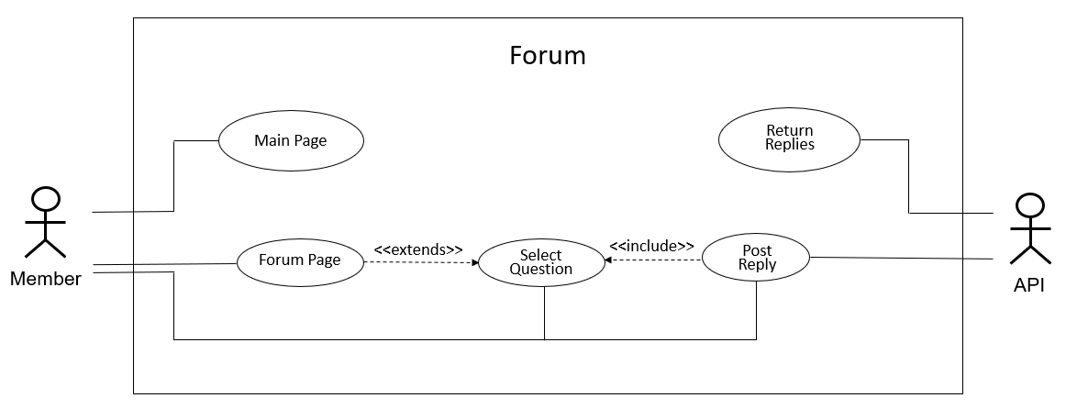UML Use Case Diagram:

UML Sequence Diagram:

